ACTION LEARNING PROJECT QUESTIONS



BUMK 776: ACTION LEARNING PROJECT

Title:

Team Number: #1

Group member names:

Heven Abraha, Haotian Du, Rutendo Nyoka, Julia M. See

- How have total campaign/deliverable volumes changed over time (month-over -month and year-over -year)?

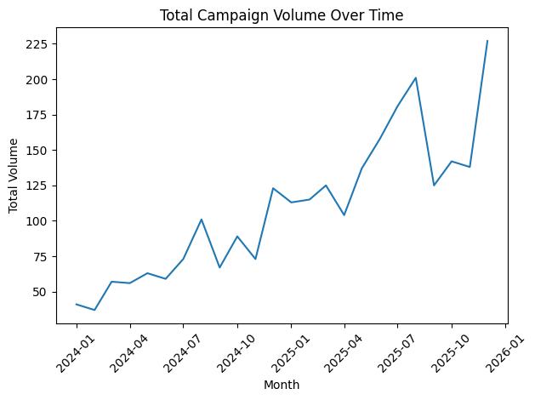
From early 2024 through late 2025, total campaign volume shows a strong upward trend. The Key observations are broken into three parts:
Early 2024:40–60 campaigns per month
Mid–late 2024 : Gradual climb to 100+ per month
And finally, in 2025: Significant acceleration, peaking at 225 campaigns, in later months

There are a few temporary dips, but the overall direction is clearly upward. The overall conclusion is that month-over-month growth is volatile but consistently trending upward, especially in 2025.

When comparing year-to-year, we compare 2025 vs 2024, total volume increased substantially.The data shows that most LOBs increased year-over-year. Several LOBs more than doubled volume, and a few LOBs declined slightly.Overall, the 2025 total campaign volume is significantly higher than 2024, driven by major expansion in specific business lines.

- Which Lines of Business (LOBs) are driving the change in volume year-over -year?
The Major Growth Drivers in chart form are:
LOB | 2024 Volume | 2025 Volume | YoY % Change
ANON_LOB_0007 | 183 | 593 | +224%
ANON_LOB_0008 | 173 | 373 | +116%
ANON_LOB_0004 | 208 | 330 | +59%
ANON_LOB_0010 | 22 | 56 | +155%
ANON_LOB_0006 | 26 | 43 | +65%

Biggest Absolute Contributor is ANON_LOB_0007
- Added +410 campaigns YoY.Primary driver of total company growth.

LOBs That Declined
LOB | YoY Change
ANON_LOB_0013 | -80%
ANON_LOB_0012 | -29%
ANON_LOB_0001 | -5%
These declines were relatively small compared to the gains from high-growth LOBs.

Overall Trend:
- Strong and accelerating growth from 2024 - 2025
- Momentum increases sharply in mid-to-late 2025
Growth is concentrated in a few high-performing LOBs. The business is scaling unevenly, with certain segments driving the majority of expansion.

- How does work mix shift by request type over time (ad hoc vs recurring vs updates to recurring)?

Work mix shift by request type over time showing actual values

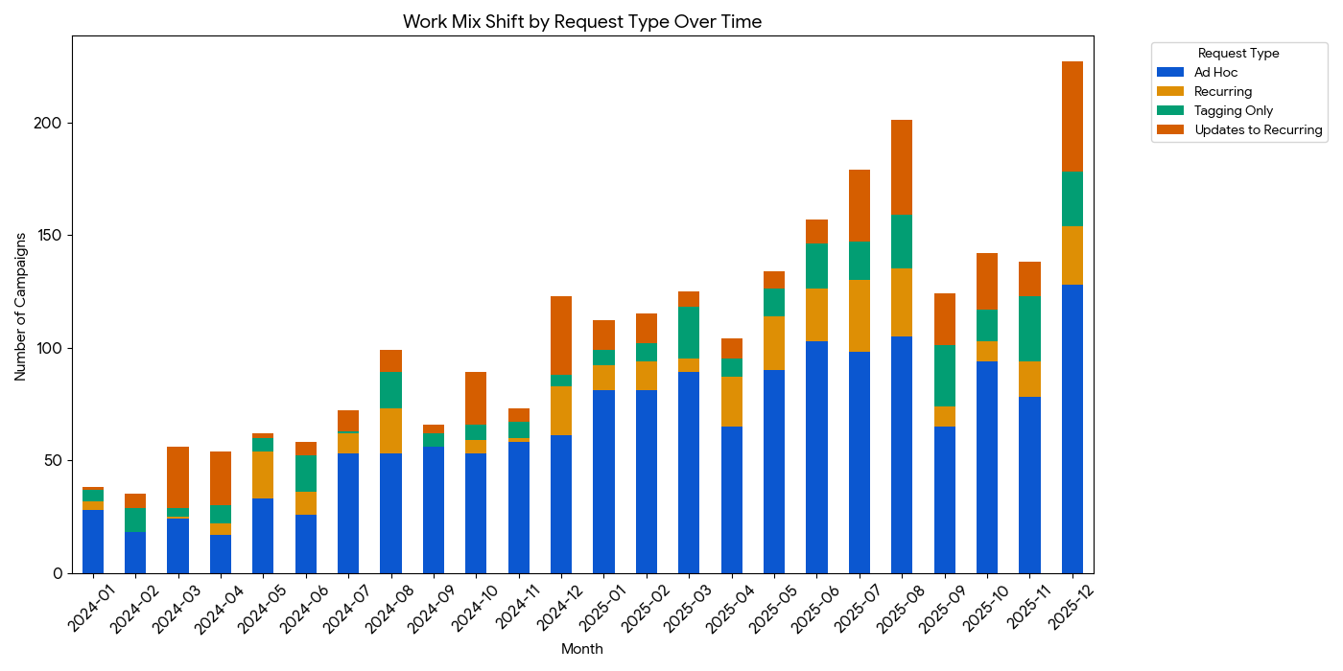

Work mix shift by request type over time showing as percentages
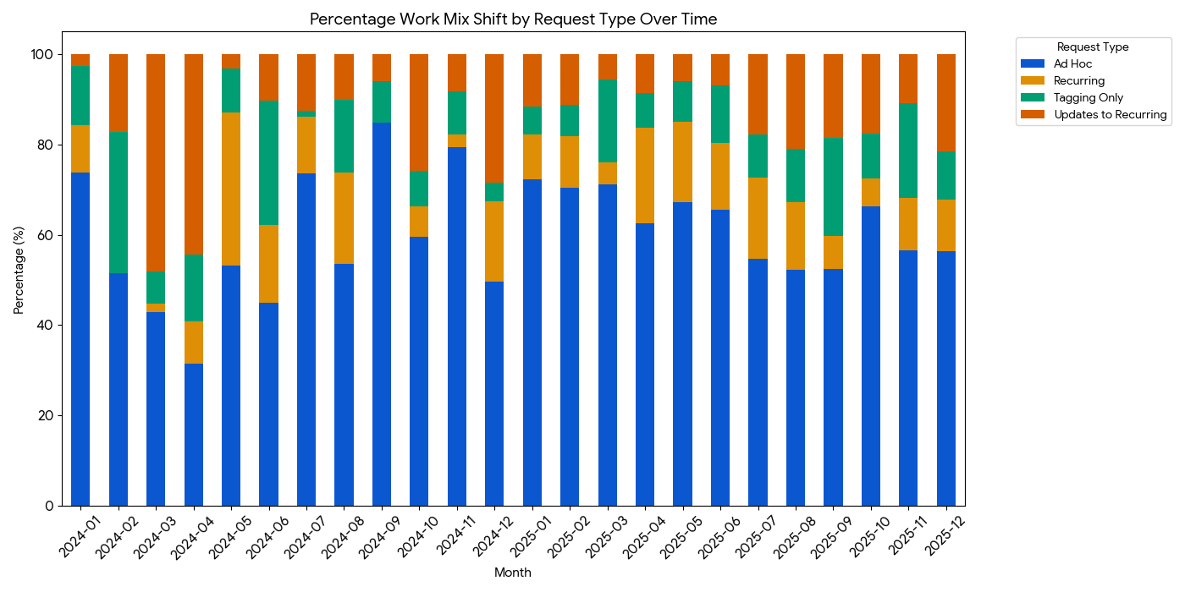

The work mix for VML refers to the requests classified into Ad Hoc, Recurring (New), Updates to Recurring, and Tagging Only.
The data shows the dominance of Ad Hoc. These Ad Hoc campaigns consistently represent the largest share of the workload approximately 60% of total volume. This indicates a highly reactive environment where the CRM Operations team must manage once-off deployments frequently.
On Recurring Workload, while recurring - new campaigns or initial setup appear in smaller bursts of around 15.5% of total volume, updates to recurring represent a significant ongoing maintenance effort with approximately 12.4% total volume . Over time, the volume of updates has remained steady, showing that once a campaign is set up, it requires continuous refinement. Tagging was approximately 11.8% of total volume.
Scalability Concern: The high percentage of Ad Hoc work suggests a potential area for optimization. If Ad Hoc requests are predictable, converting them into Recurring workflows could save significant billable hours

Strategic Implication
The team workload is not structurally shifting away from Ad Hoc ,it remains dominant.However, with recurring work spikes periodically, suggesting Campaign lifecycle maturation, scaling automation efforts and increasing operational complexity.
If the goal is operational efficiency, reducing Ad Hoc dependency would stabilize workload.
- How is volume distributed by channel, and how is that changing over time? (e.g., Email vs SMS vs Push vs Tag/QR.

Volume Distribution by Channel
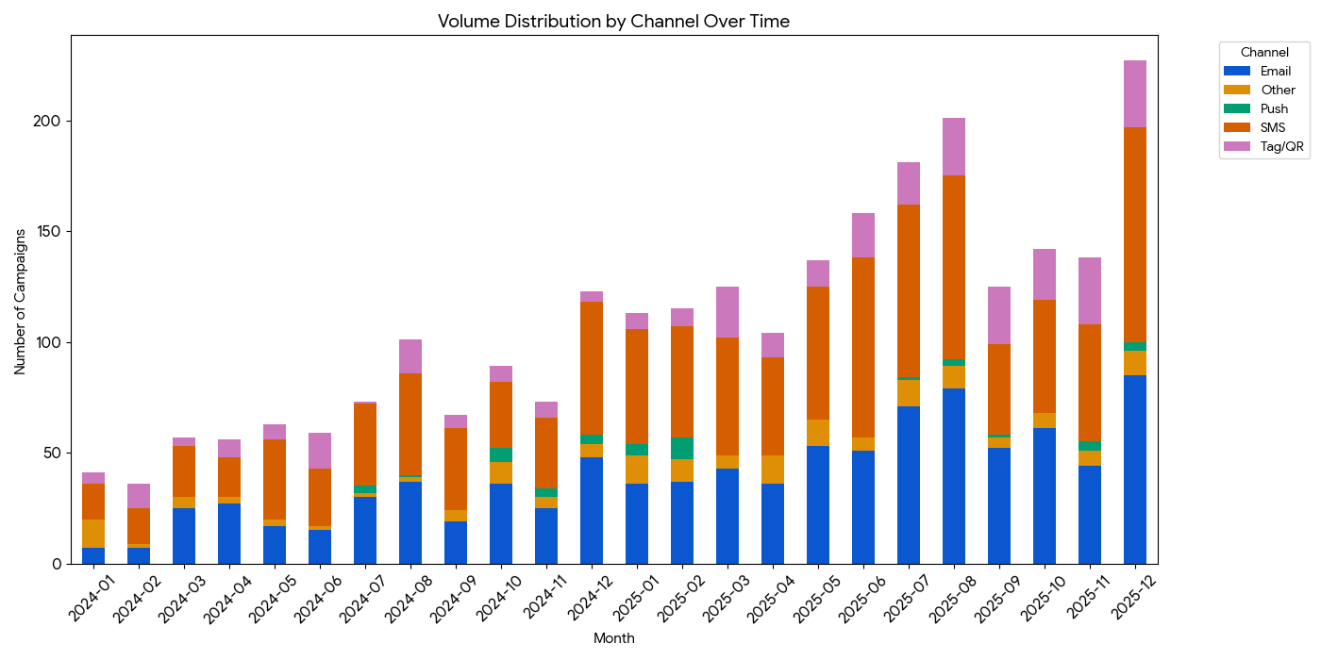
The volume was grouped into five major categories: Email, SMS, Tag/QR, Push, and Other.SMS & email are the primary communication channels. The growth trend for the total campaign volume across all channels shows a general upward trend from 2024 into 2025.
SMS & Email Lead the Way
SMS and Email are the primary communication channels, together accounting for the vast majority of all deployments.
Rise of SMS: There is a noticeable trend where SMS volume has grown to rival or occasionally exceed Email volume. This highlights an increasing reliance on mobile-first, short-form messaging.
Tag/QR Consistency: Tagging and QR code requests maintain a stable, moderate volume throughout the period, reflecting a consistent need for tracking and physical-to-digital bridge assets.
Push Channel: Mobile Push remains the smallest segment of the mix, suggesting it is either a secondary channel for this client base or is managed through a different operational workflow.
The CRM Operations workload remains predominantly Ad Hoc, suggesting reactive demand continues to outweigh structured automation. Meanwhile, channel volume is heavily concentrated in SMS and Email (75%+ of total output), indicating operational dependency on two primary channels with limited diversification into Push or emerging formats.
- Are we doing more “simple vs standard vs complex” work over time (i.e.,effort/complexity mix)?

Simple VS Complex Work Over time:
​​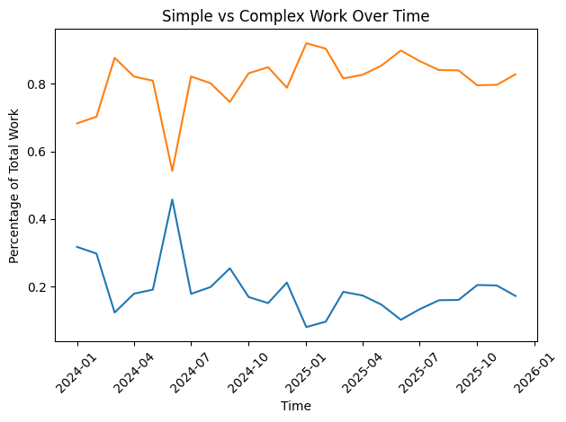
Complex work remains under 20% for most of the year, with Simple work representing the majority of volume.
- The higher line (around 80–90%) = Simple work
- The lower line = Complex work
- Complex work appears to decline after early spikes
- Simple work consistently dominates the mix
Simple VS Standard Work Over time:
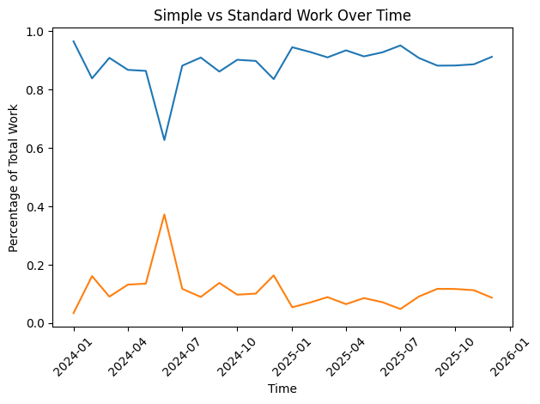
Standard work represents a small portion of total execution and has not shown sustained growth over time. The portfolio remains heavily weighted toward simple work.”
- Simple work dominates heavily roughly 85–95% most months when isolated against Standard.
- Standard work is consistently low, with one visible spike mid-year.
- There is no sustained upward trend in Standard it fluctuates but remains minor.
Standard VS Complex Work Over time:

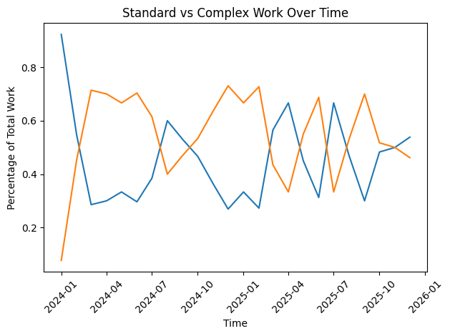
When isolating Standard and Complex work, neither shows sustained growth over time. The mix fluctuates month-to-month without a clear structural shift toward higher complexity.
- Early on, Complex dominates when compared only to Standard.
- Over time, the relationship becomes more volatile; they trade places several times.
- There is no consistent upward trend in Standard overtaking Complex long-term.
- The mix between these two categories fluctuates month-to-month rather than trending steadily.

- What are the biggest outliers (large campaigns/projects) and what is driving them?
The biggest outliers (large campaigns/projects) are concentrated in a small number of LOBs and are primarily driven by recurring-update and EM/Complex EM work patterns, rather than the high-frequency simple Ad Hoc work that is fueling overall volume growth.

1. Where the Outliers Sit
a) Specific LOB Concentration
- The largest campaigns are disproportionately clustered in a few LOBs rather than being evenly distributed.
- This indicates concentration risk: a small subset of business lines is responsible for a large share of total output.
b) Recurring-Update Projects
- Although Ad Hoc volume increased overall, the largest individual campaigns are tied to recurring-update work.
- These projects likely involve ongoing lifecycle communications, retention programs, or structured recurring pushes.
- Recurring work tends to accumulate higher total volume over time, which makes them appear as outliers.
c) EM / Complex EM Patterns
- Large outliers are also associated with EM and Complex EM initiatives.
- These projects likely:
  - Require heavier coordination
  - Involve multiple touchpoints
  - Have broader targeting or larger audience segments
- Even though complex work declined as a share of total volume, when it does occur, it drives disproportionate volume impact.

2. What Is Driving the Outliers?
From your analysis, the drivers appear to be:
1. Scale Within Specific LOBs
- A few high-performing or high-priority LOBs are launching repeat, large-scale campaigns.
- Growth is not coming from diversified expansion but from scaling within those pockets.
2. Recurring Operational Programs
- Lifecycle or ongoing programs (e.g., monthly/quarterly pushes) generate cumulative high volume.
- These naturally become statistical outliers over time.
3. EM / Complex Execution
- Even though overall complexity share is declining, the largest campaigns are tied to higher-effort EM patterns.
- These likely involve:
  - Multi-channel activation
  - Broader audience reach
  - Coordinated deployments
4. High-Throughput Operating Model
- The 2025 model favors speed and repeat execution.
- Once a campaign template/process is built, it can be scaled quickly—creating volume spikes in certain programs.

3. Strategic Interpretation
The biggest outliers are not random spikes—they are:
- Concentrated in specific LOBs
- Driven by recurring-update programs
- Amplified by EM/Complex EM structures
This reinforces two implications:
- Revenue/volume dependency risk – Growth is heavily reliant on a small number of business lines and recurring programs.
- Operational imbalance – While most growth is coming from simple, high-frequency work, the largest strategic bets still sit in more complex EM-driven initiatives.

Q1-6 Visualization Charts
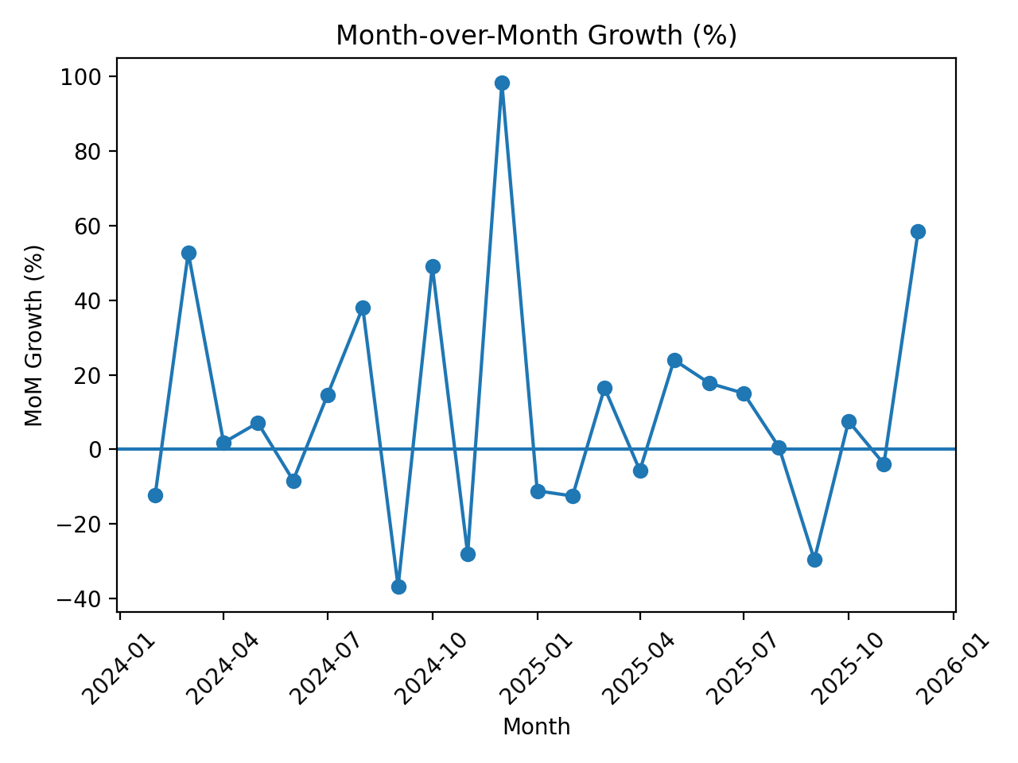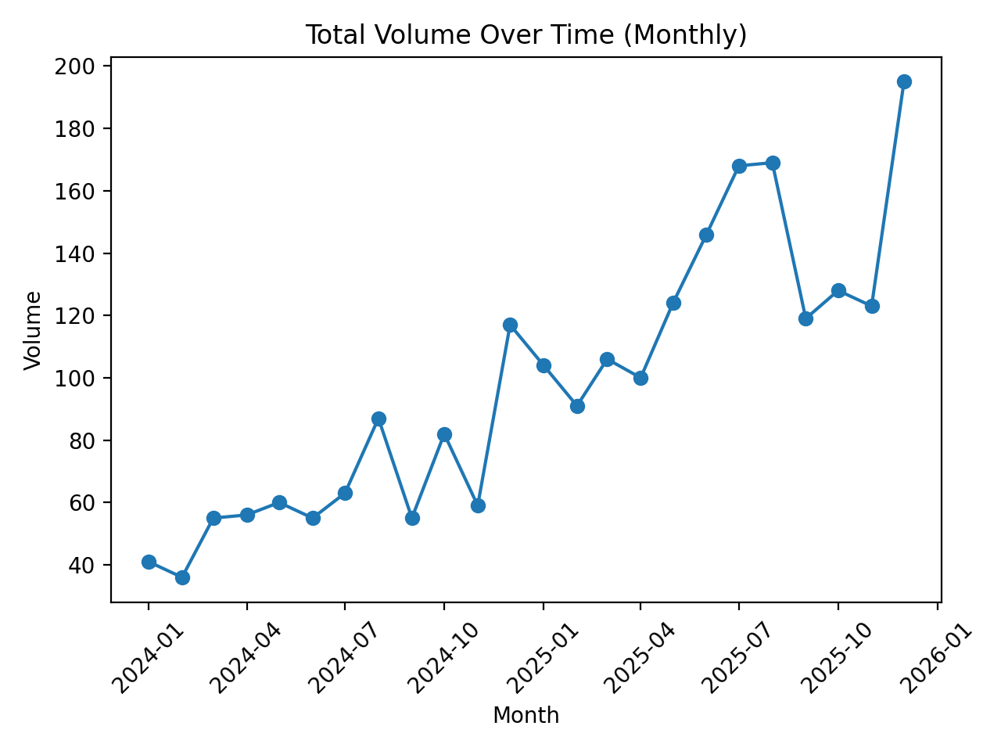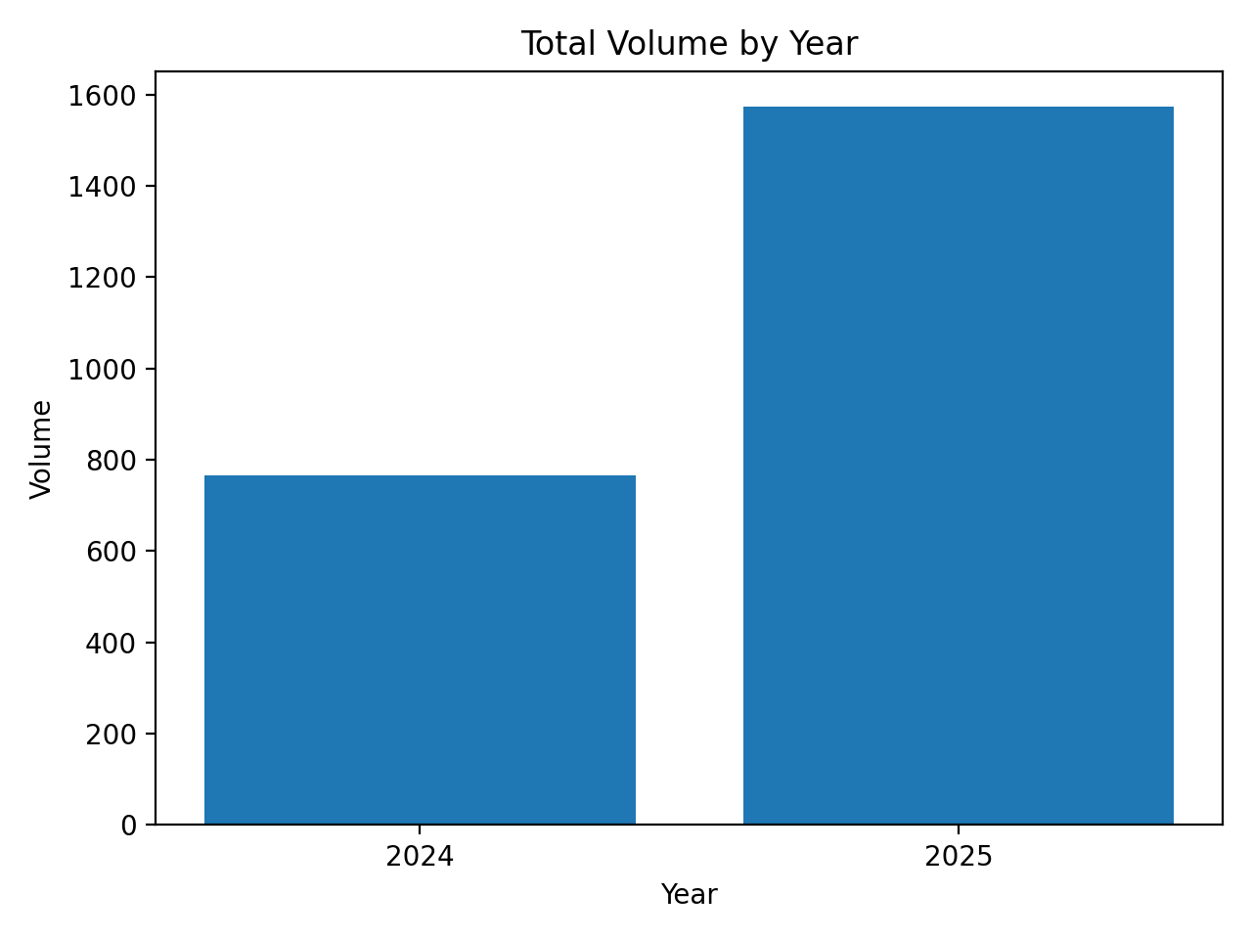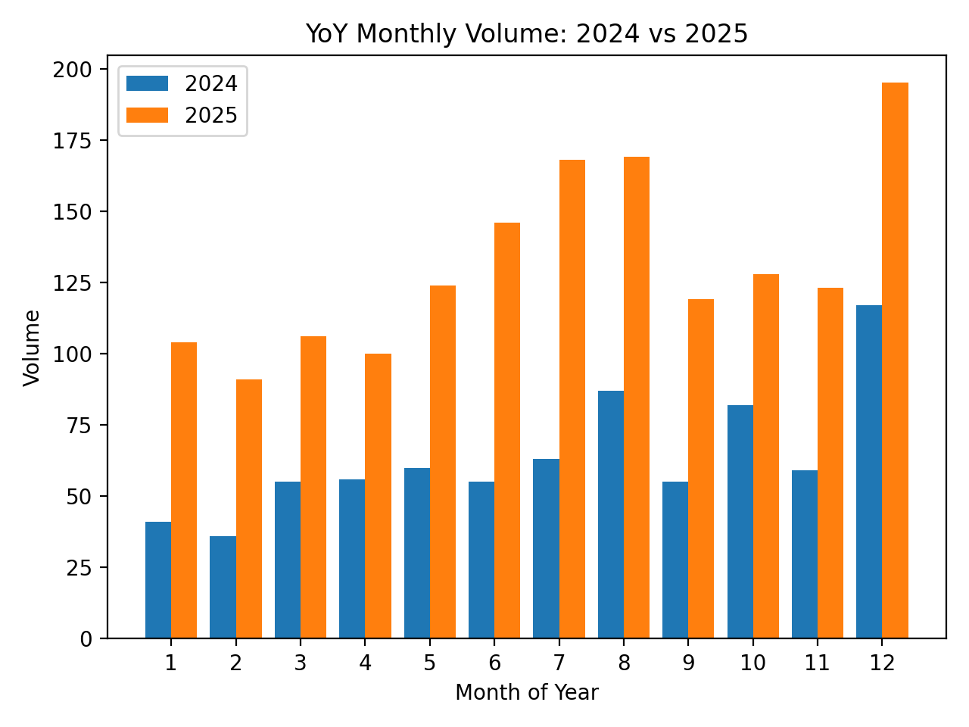

Q2
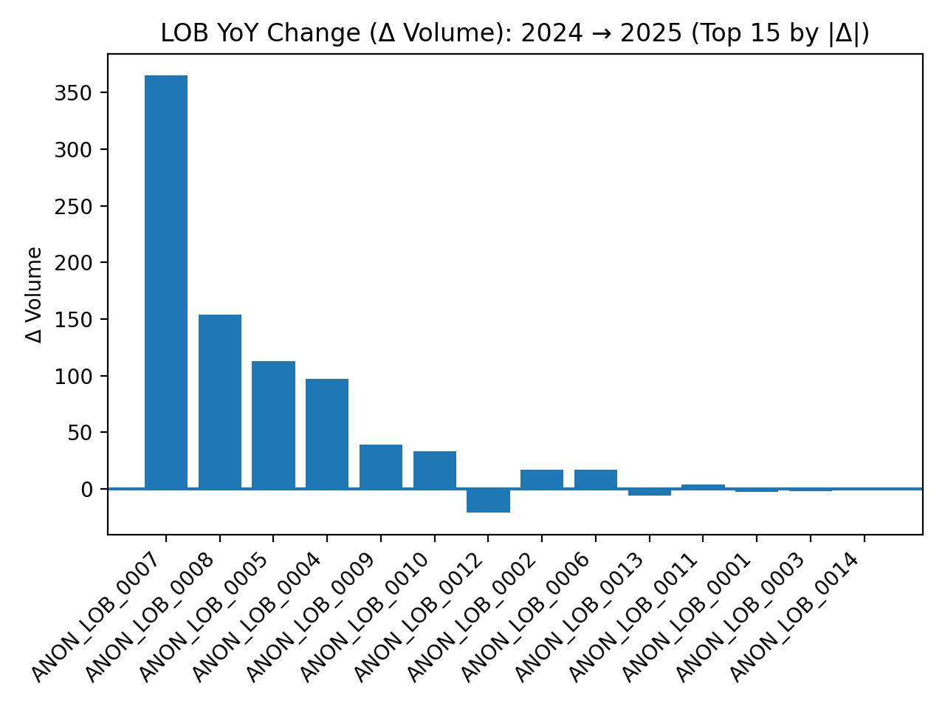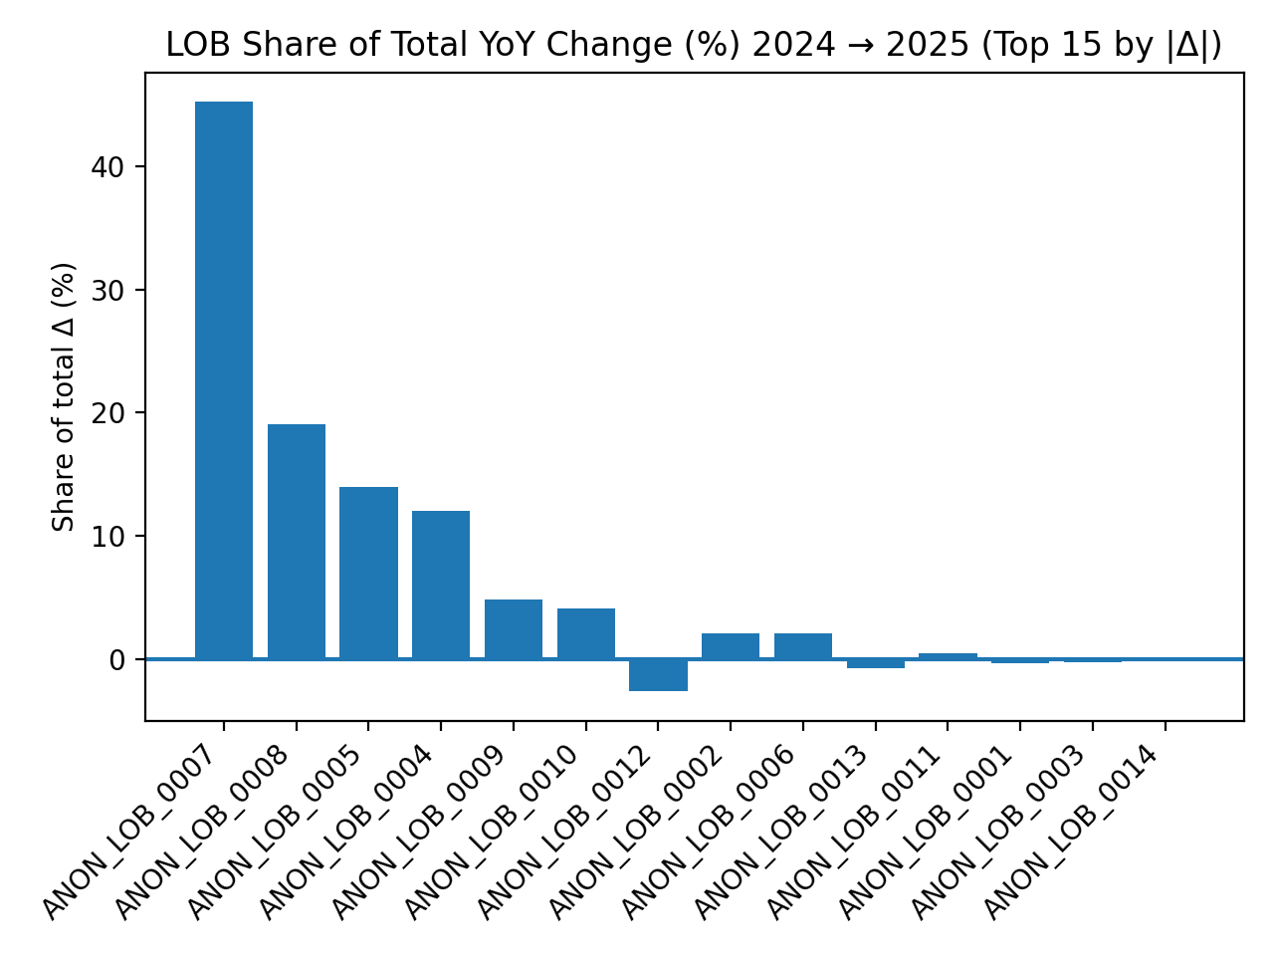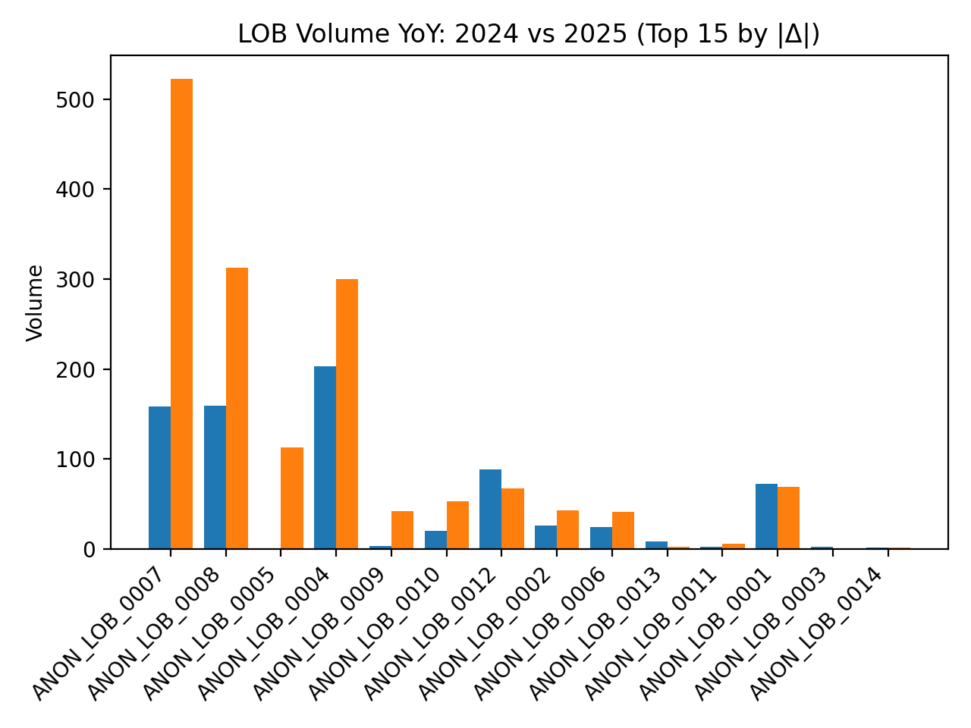

Q3
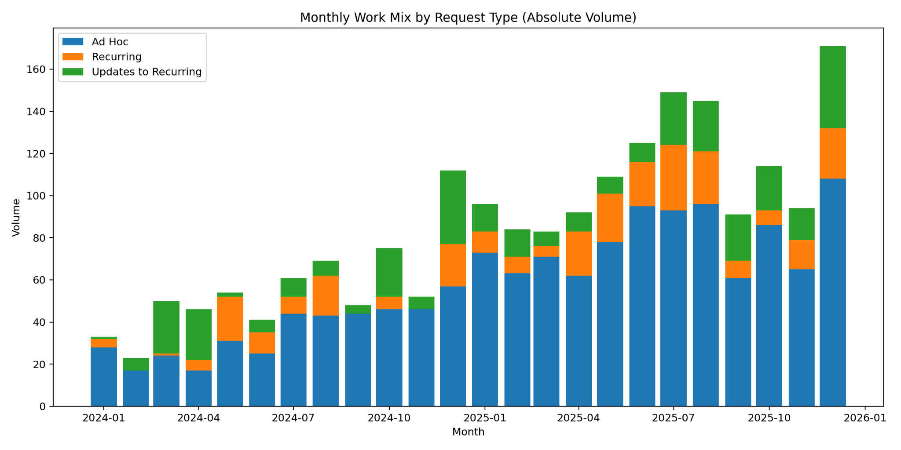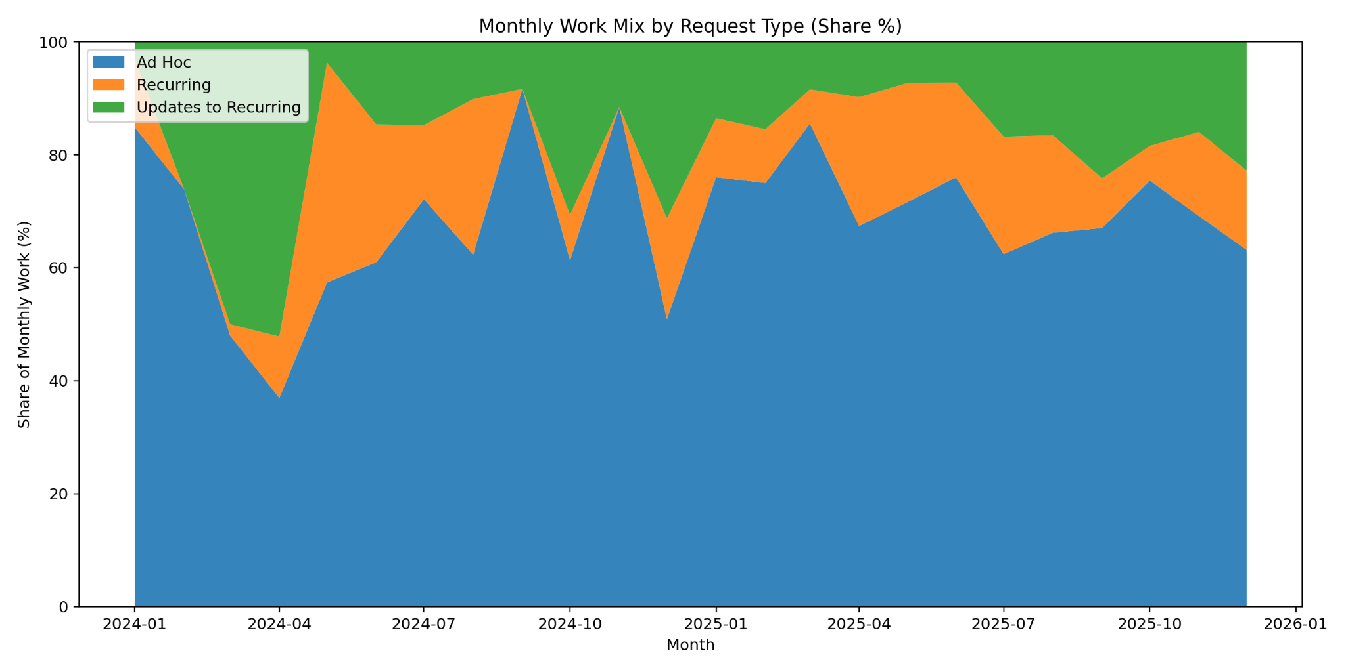

Q4
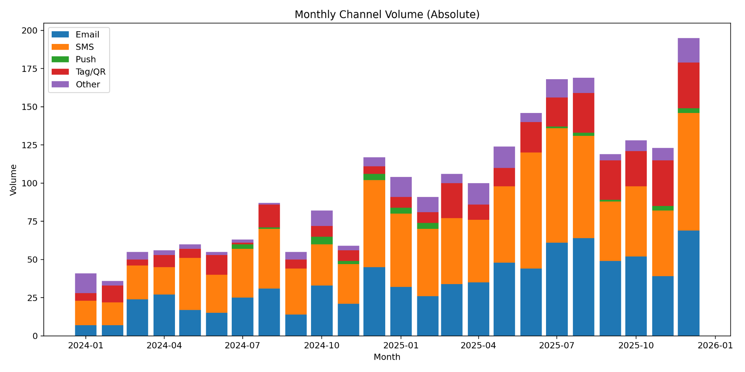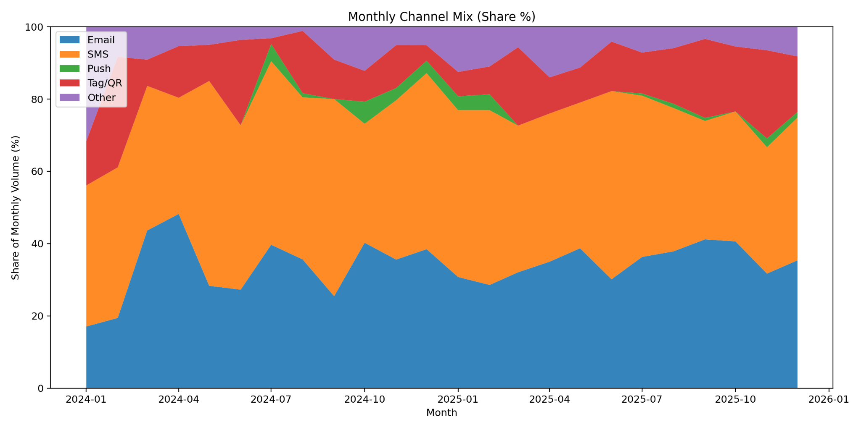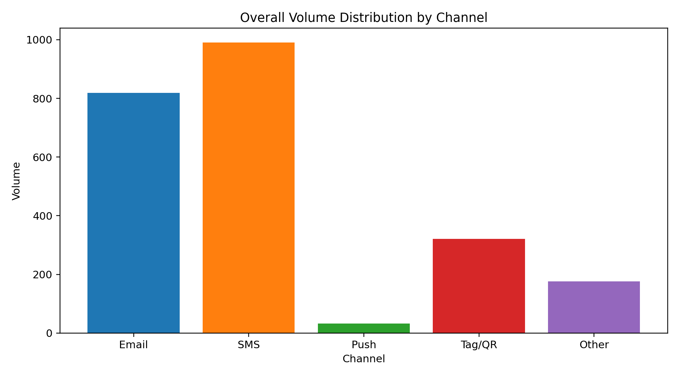

Q5
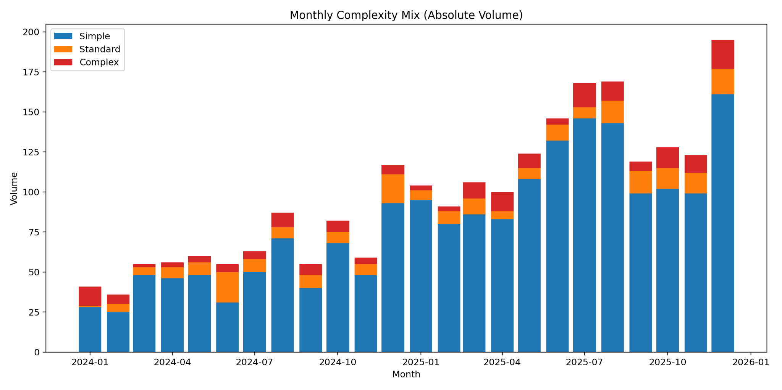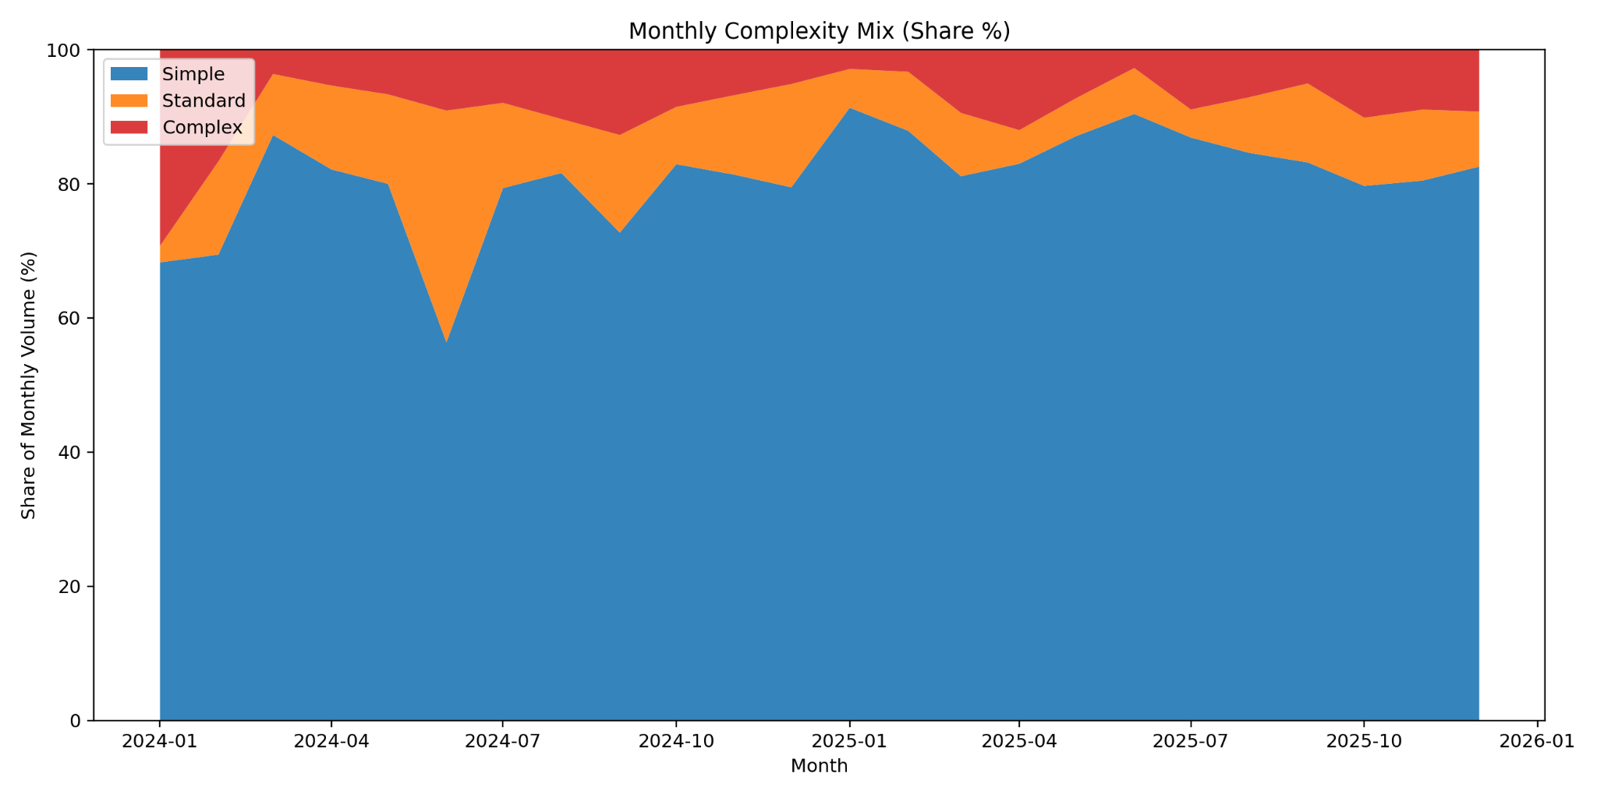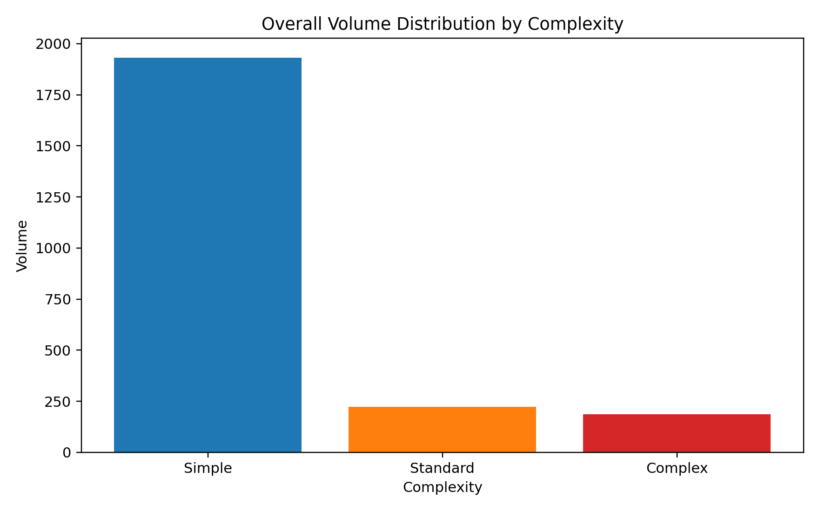

Q6
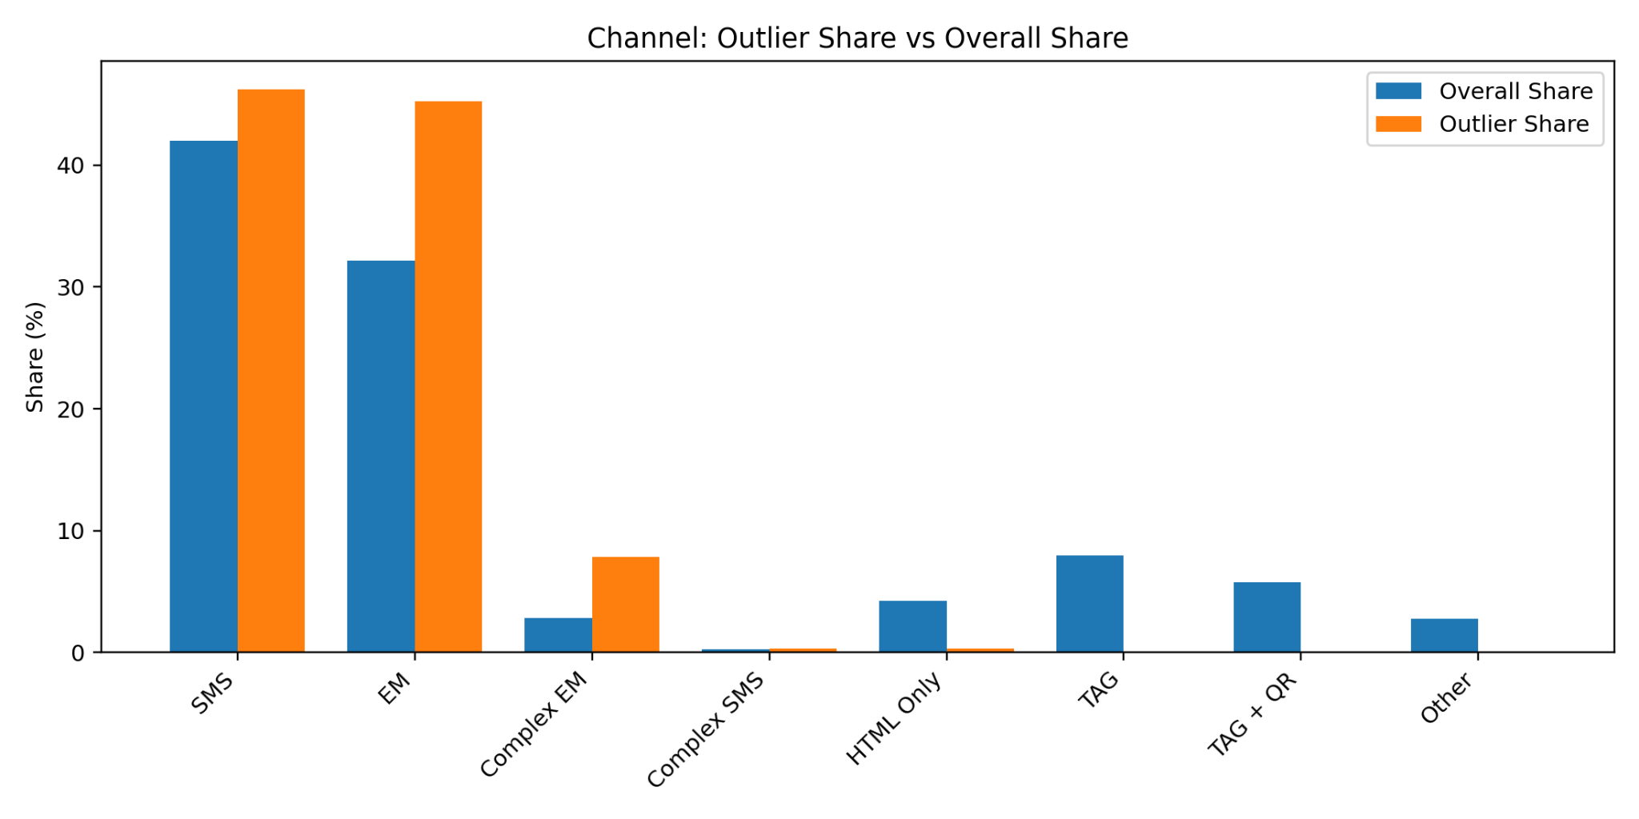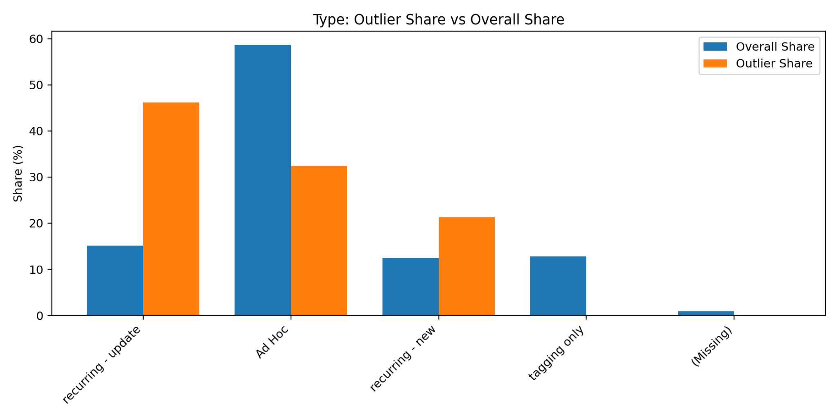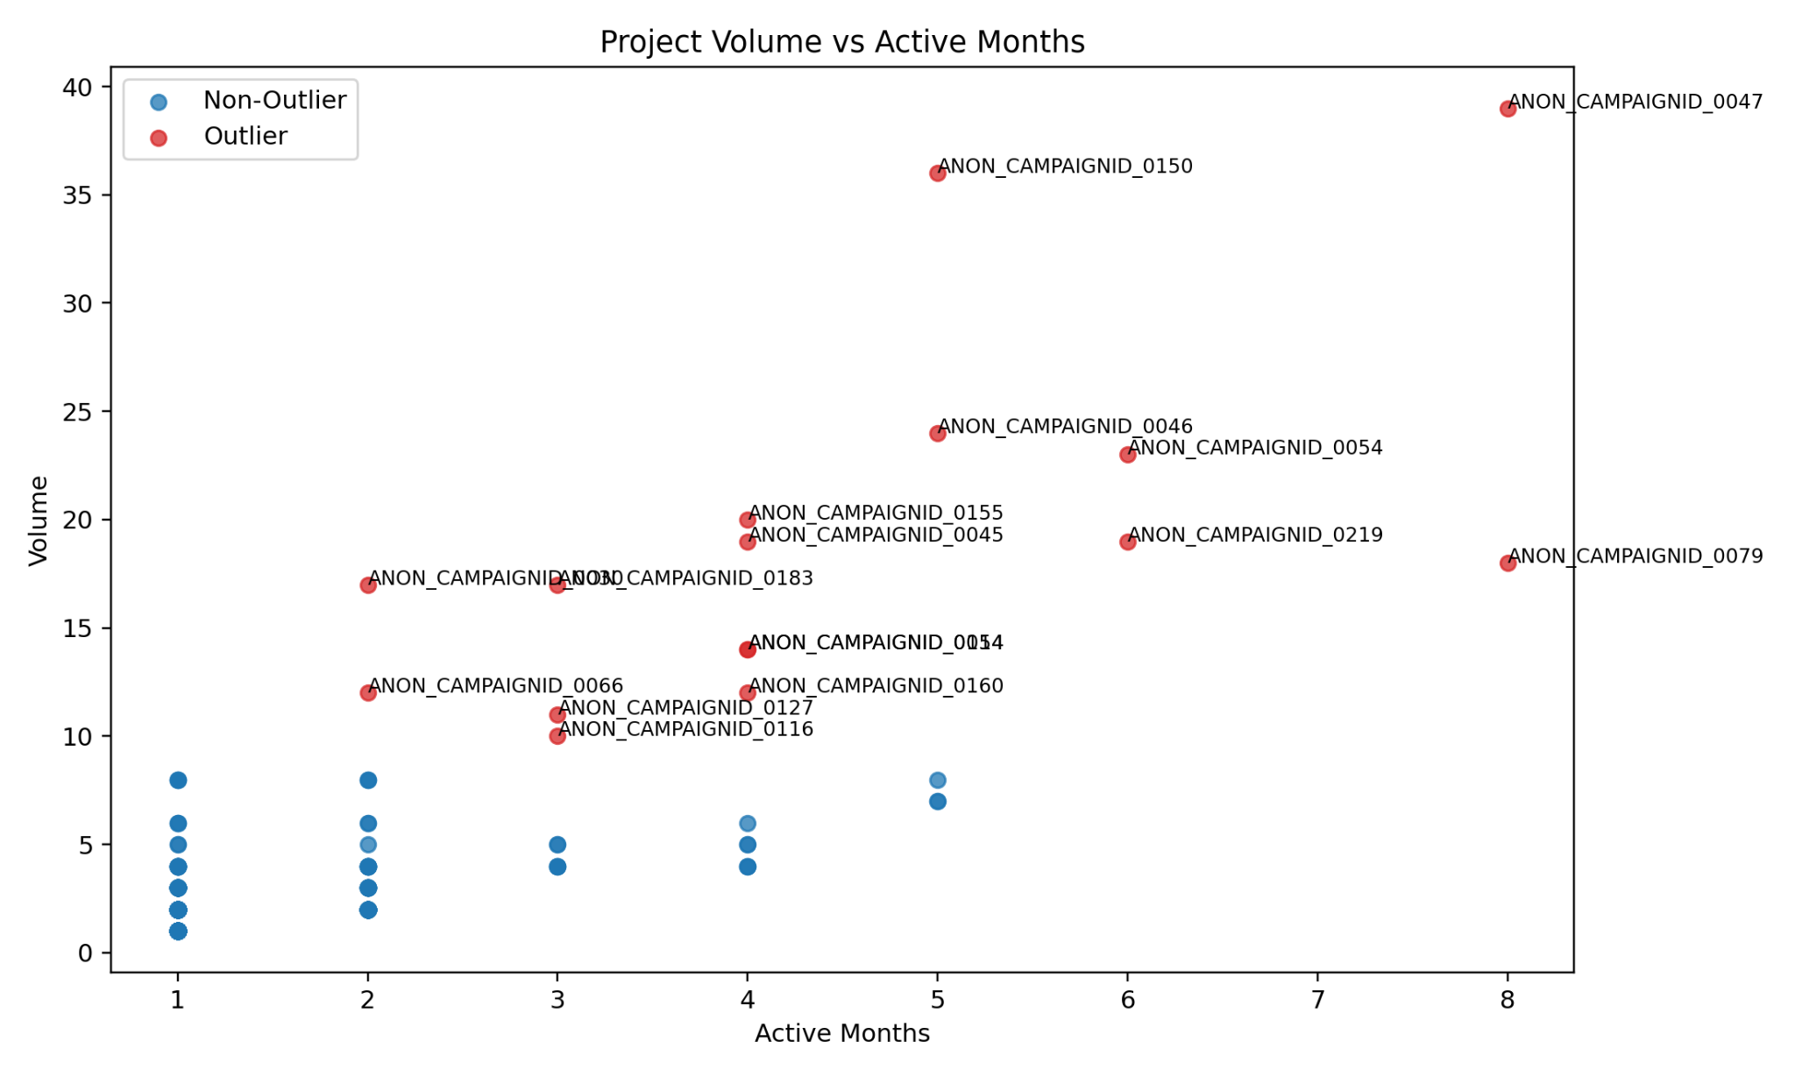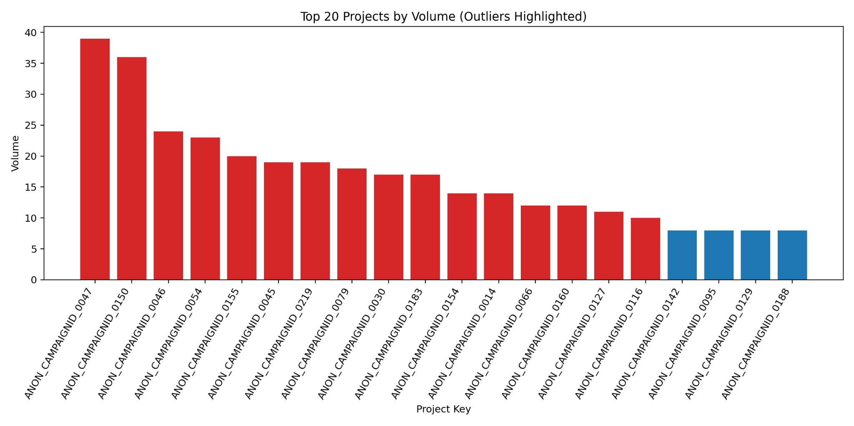
Across all six analyses on the same campaign tracker dataset, the key story is that the team moved into a strong growth phase in 2025: total volume increased from 766 in 2024 to 1,573 in 2025, a year-over-year gain of about 105%. However, this growth is not broadly distributed; it is concentrated in a small number of LOBs and a set of high-volume outlier projects. The work mix is also shifting toward faster-turnaround execution: Ad Hoc work rose from 63.6% to 70.3%, while recurring-update share declined. Channel mix shows structural change as well: SMS remains the largest channel but lost share, Tag/QR gained share meaningfully, and Email stayed relatively stable. At the same time, the effort mix is becoming simpler: Simple work increased from 77.8% to 84.8%, while Standard and Complex shares declined, indicating that most of the volume expansion came from high-frequency, lower-complexity work rather than growth in complex initiatives. Outlier analysis reinforces this pattern, showing that the biggest projects are disproportionately associated with specific LOBs and with recurring-update and EM/Complex EM patterns. Overall, the operating model today is high-throughput and execution-heavy, with growth concentrated in a few pockets; the strategic priority should be to sustain delivery speed while rebalancing toward more medium-to-high complexity work and reducing concentration risk across LOBs and project types.






